MILTON – THURSDAY NOVEMBER 6, 2003

Sam Sherratt School:

Games start at 7:45pm

401 West to 4th line / James Snow Parkway exit (exit number 324)
Go South (Turn Left onto James Snow Parkway)
Take a Slight Right onto Main St. E
Turn Left onto Thompson Rd. S.
Turn right onto Laurier – school is at 649 Laurier Ave.

Alternate Route (or if you miss the Main St. E. turn):

401 West to 4th line / James Snow Parkway exit (exit number 324)
Go South (Turn Left onto James Snow Parkway) to Derry Road and turn right
Take Derry and turn right onto Ontario St. (formerly Hwy 25).
Take Ontario and turn right onto Laurier (1st North of Derry). school is at 649 Laurier Ave.

FLAMBOROUGH - TUESDAY DECEMBER 2, 2003

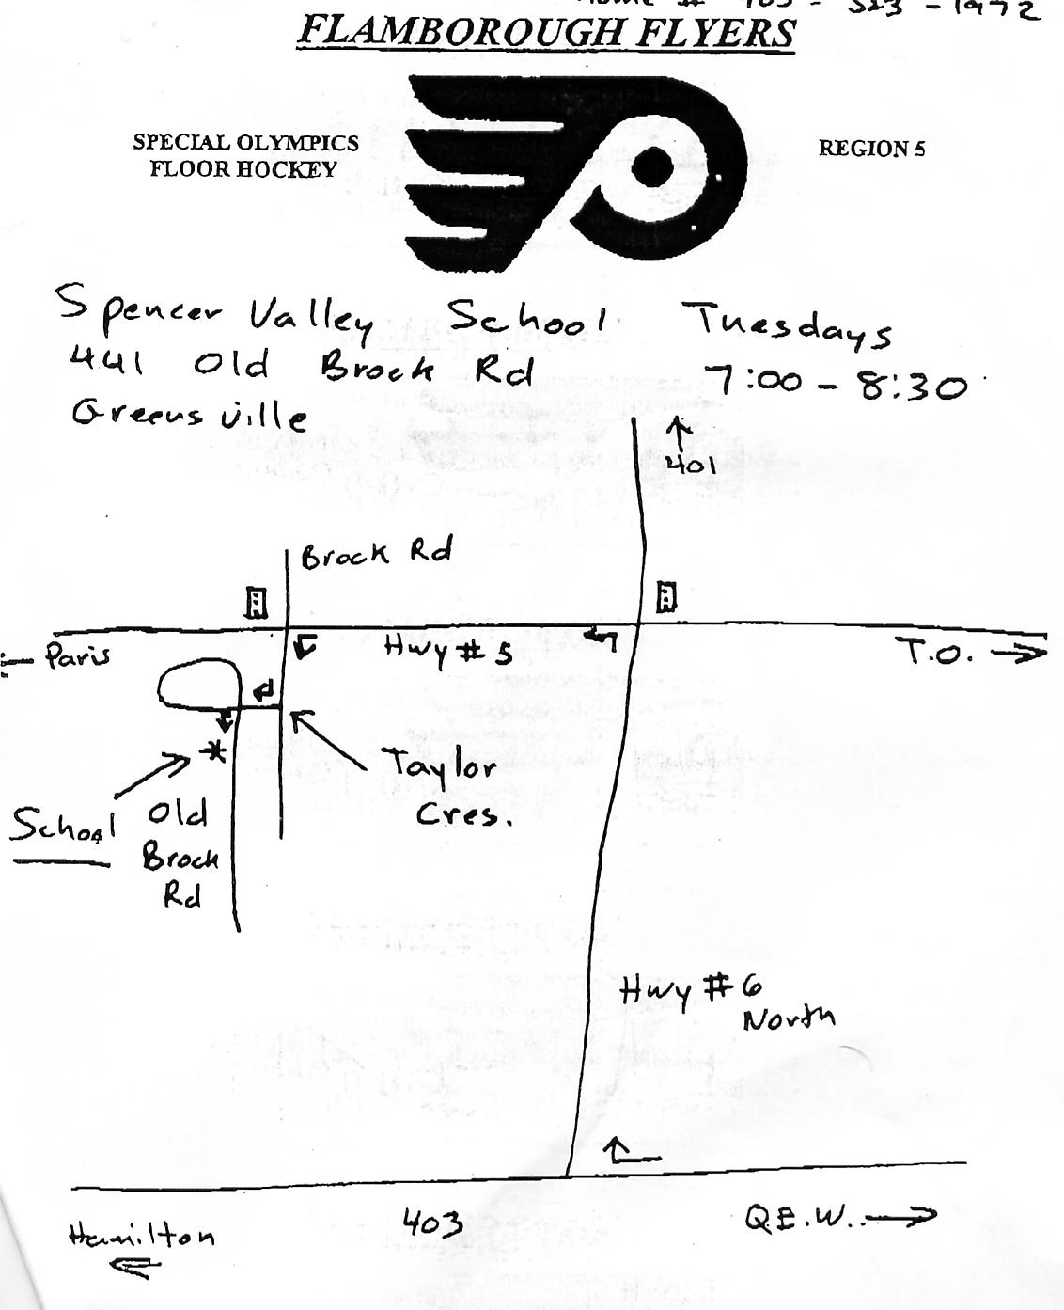
6:50 – 8:50pm

HAMILTON – MONDAY JANUARY 19, 2004

Pinky Lewis Recreation Centre on Wentworth St. North.

6:30 - 7:30 p.m.

Directions:

QEW to 403 Hamilton. You would take the York St exit and follow it through the city. After Copps Colliseum this street turns into Wilson St. and you will follow it to Sanford Avenue (there is a stoplight). Turn left on Sanford and follow Sanford past Cannon St. You will pass a school on the left and you will turn into the driveway just past the school. This is the entrance to the recreation centre. The rec centre is positioned in between Sanford and Wentworth St..

BRAMPTON – THURSDAY FEBRUARY 5, 2004

Greenbrier Senior Public School.

6:30 to 8:00pm

Directions

410 North to Queen Street Exit.
East(Right) on Queen to Bramalea Rd.(Its Dixie then Central Park then Bramalea.
North(left) on Bramalea Rd. to Central Park Drive(I think its the first light)
East(Right) on Central Park Drive for about 2 miles and the school and the rec. center are on the right hand side. From the parking lot the arena is straight ahead and the school is down the hill on the right. Just knock on the big brown gym door

